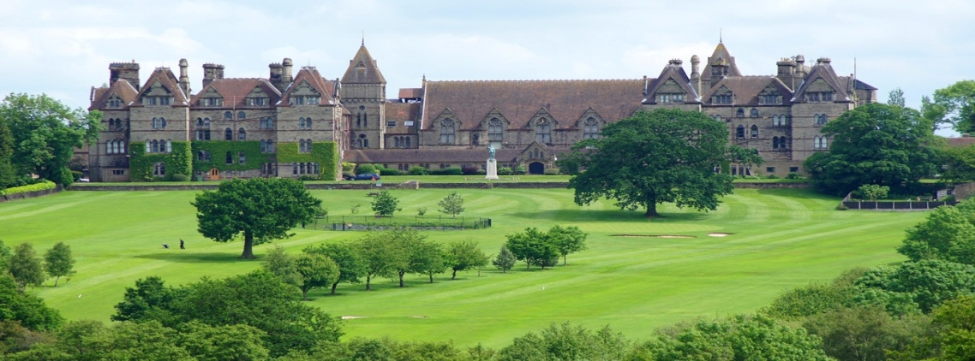
The Course
The British Academy of Fencing’s residential course is open to all fencing coaches irrespective of whether they are members of the BAF.
The course is designed for fencing coaches who wish to improve or enhance their practical skills, increase their technical/tactical knowledge or to simply meet other coaches and share ideas and experiences. The course is also ideal for those wishing to prepare and take BAF examinations. Optional examinations are held on the Saturday for those who wish to take BAF coaching awards.
There will be nightly optional specialist training events which will look at the wider aspects of coaching and the sport of fencing.
The sports hall at the venue is available for use by course members until late in the evening for those who desire.
There is also a non-residential option if you do not wish to stay at Denstone College, for further information on this please contact the course officer.
Whilst the course might be considered to be intense there is also a focus on learning should be fun and enjoyable.
The Venue
Denstone College, Denstone, Uttoxeter, Staffordshire, ST14 5HN
Denstone College is set in heart of the UK, in the Staffordshire country side. Once at the college you will not need to travel anywhere as all training and dining is on site which is included in the course fee. There is ample free car parking at the college if required.
Within easy access to the college is a local pub and shops if needed. A short car journey away is the local town of Uttoxeter where there are a range of shops including a Tesco, where is necessary you can purchase any forgotten items.
The College is within one hour’s drive of three major airports: Manchester, East Midland and Birmingham, and the nearest mainline stations are Stafford, Derby, Stoke on Trent and a branch line at Uttoxeter.
Accommodation
The accommodation at Denstone will be single rooms in a self contained block of the college. There is use of a common room which has a TV and kitchen facilities available which you will be able to use if required, (washing machine etc).
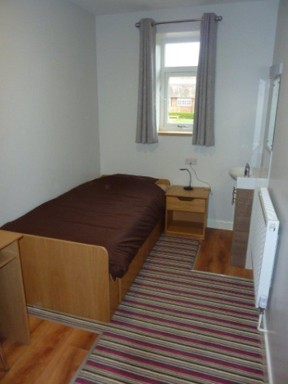
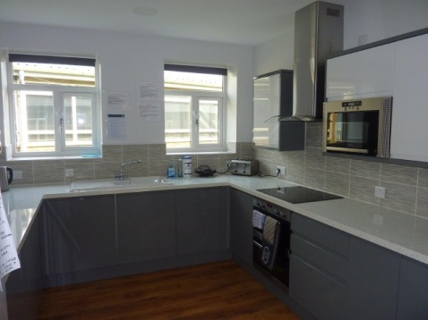
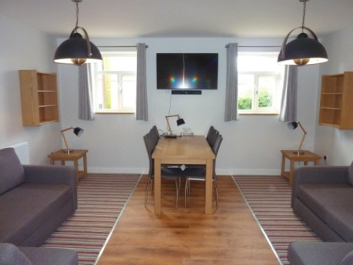

Cost
British Academy of Fencing Members : £444 Non Academy Coach: £499
This fee includes full board (breakfast, lunch and evening meals), tuition and course documentation. Examination fees are extra.
Applications received later than 28 days prior to the course start must be paid in full and a late application fee of £40 will be added to the course fee. A deposit of £75 (non-refundable or transferable) is payable to the BAF on application.
Places will not be reserved until the deposit is received.
Overseas candidates are required to pay the full course fee upon application. Overseas candidates my request a refund, less £75, up to 4 weeks prior to the course,balance must be paid 8 weeks prior to the commencement of the course. If the balance is not paid by this date then your place may be cancelled and the deposit will not be refunded. If you cancel your place within 28 days of the commencement of the course, then the course fee will not be refunded.
Cheques should be made payable to “British Academy of Fencing”

If you wish to apply for the course or obtain further information please contact Mrs Jacqueline Redikin:
jredikin@hotmail.co.uk or via post 10 Beverley Ave, Davyhulme, Urmston, Manchester, M41 0RY, England, United Kingdom.
Please Note: You must be aged over 18 to attend the course
Application form
Fee, Academy Members : £444 Non Members: £499
This includes full board, tuition and course documentation, but does not include the examination fee.
Applications received later than 28 days prior to the course start must be paid in full and a late application fee of £40 will be added to the course fee. Deposit of £75 (non-refundable or transferable) payable to the BAF on application.
Places will not be reserved until the deposit is received.
Overseas candidates are required to pay the full course fee upon application. Overseas candidates my request a refund, less £75, up to 4 weeks prior to the course ,balance must be paid 8 weeks prior to the commencement of the course. If the balance is not paid by this date then your place may be cancelled and the deposit will not be refunded.
If you cancel your place within 28 days of the commencement of the course, then the course fee will not be refunded.
Cheques should be made payable to “British Academy of Fencing”
Bank Transfer Details:
Bank: HSBC 20 Market Place Stowmarket IP14 IDW
Account Name: British Academy of Fencing
Account No: 41501089
Sort Code: 40-43-37
Title _____Name __________________________________________________________
Address _____________________________ ____________________________________
____________________________________ Post Code ___________________________
Email Address ________________________ ____________________________________
Tel Number __________________________ Membership Number __________________
Weapon to study ____________________________ Level of study_______________________________
E-mail will be the primary method of contacting candidates .All attendees must be fencers and over 18 years old.
I ___________________________________ (print name) agree to the conditions and I accept that failure to comply will result in my place on the course being cancelled
Signed ____________________________________ Date ________________________________
To apply for the course please complete and return this form (keeping a copy for your records) to:
Mrs J. A. Redikin, 10 Beverley Ave, Davyhulme, Urmston, Manchester, M41 0RY, England, United Kingdom.

